**Higher Diploma in Computing – Part-Time 2014**

**Semester 3**

**Course Module: Software Engineering for Web Applications**

**(**HDC-SEWA)

**Main Assignment – Description / Research Documentation**

**Student Names: Gavin McGovern, Frank Deasy, Cathal Mulkere**

**Student ID Nos.: 2862213, 2864260, 2859287**

**Lecturer: Mark Scanlon**

**Date Due: 05-01-2015**

Introduction

GFC-Stats.com is happy to present the first version of a new dynamic website with a lot of potential. Having reviewed current offerings on the web in relation to statistics available on various sports a perceived gap exists in the market for a site targeted at sportspeople on which they can record and compare their performance in both training and matches against their peers and competitors.

An interactive website prototype has been developed initially designed for GAA football players but with scope to translate to other sports. Users are able to record data relating to their daily training and match activities under a number of criteria onto a database that will allow them compare key aspects of their training and performances against others in their field. This comparison will be displayed by way of graphs and tables making it clear where more effort is needed and where they compare favourably to their competition.

*Note: Initial data utilised for comparison purposes is partly fictitious and used for the purposes of the draft design.*

Design Layout

Our understanding on the design layout is that we are to develop the site using HTML, PHP, CSS, Java Script and MySQL. Thus tools such a Bootstrap and JQUERY as well as more formalised functions have not been used in site design or development. These limitations refined certain aspirations we had on the functionality of the site and how we would like it to present. Thus while researching the design options we found that the majority of the more popular sites tend to create a customised format though shades of grey appear to be more popular for physical training sites. In an effort to keep the site crisp and clear we decided to use these base-colour attributes on our site.

For the prototype we have included 4 key pages.

1. A Home page which explains the reason for and benefits of the site.
2. An About us page which explains the details of the project in question, the people behind it and also explains how the site works for interested users and the likely outcomes they can achieve along with a resource library that they can access tips through various media.
3. Contact us page gives details of how to make contact with us through the various media and a location map of where to find us. We have also included and enquiry form here where users can submit specific enquires via email.
4. Profile - Analysis pages, where the user can actually start to interact with the site and review their data. To do this they must first register and login into the system.

Registration

This is a short form that each user must fill out which includes details to input for their profile. Once registered, the data inputted is recorded in our supporting database and they can then login to enter the Analysis section and begin to use the site.

Profile - Analysis

The user can input their training data for each session (be it with their Club, County, or on a Personal basis) and their match data for each match played (again be it with their Club, County, etc.). Once they have done this they will be able to compare their performance against the data per other players in the database. Ideally we would like this analysis to develop further to capture more information but initially we wanted to keep the time needed inputting data to a minimum so kept the forms short yet useful. Creating future links to download data from some of the tools available on the market would allow greater input and more relevant results. This was not considered as core functionality at this time.

Assumptions

We initially populated the database with player data from a number of inter-county players to create a base from which to compare inputs. Although the specific data isn’t accurate it correlates with the targets and schedules of best practice in the sport.

We have researched current thinking on best practice for training and performance measurement and would ultimately aim to link with some of the multiple software input devices like dartfish. Targets and online training / coaching would be an avenue we believe could be explored using expert analysis and coaches on a consultancy basis.

Site Map Diagram:

Below is a breakdown of the site map.

Registration

HOME PAGE

Contact us

About us

Login

Registration

Profile

Training History

Profile Update

Match History

The flow of the site allows users to navigate from the Home page to the About us and Contact us pages. From these pages the user can go directly to any of the other pages including the Login or Registration pages. Once logged in the user has access to the profile analysis page. From this page the user can link see information on the Training and Match history and can update their profile. On logging out they will return to the Home page.

Wireframe Diagram:

Home Page

The home page is the main landing page and its initial view will be of rotating images in the centre with a twitter feed to the right and a navigation bar to the left to offer optical balance. The menu bar on the top will be standard across all main pages

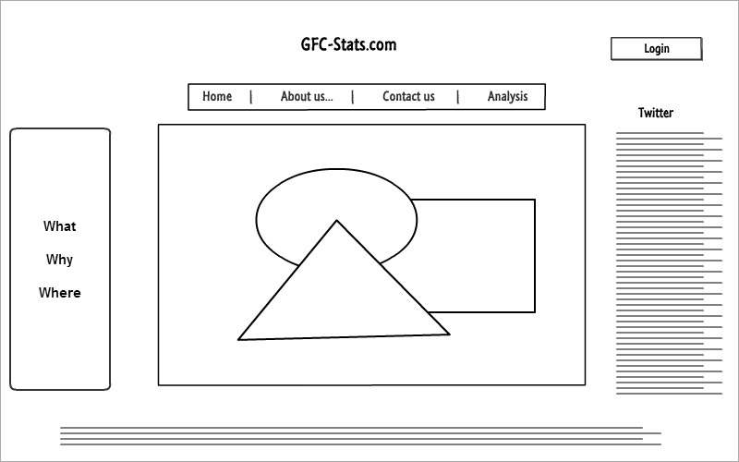

About us

The about us page is primarily an information source for users and offers details on the site how it works and some resources related to the topic for download or viewing on video

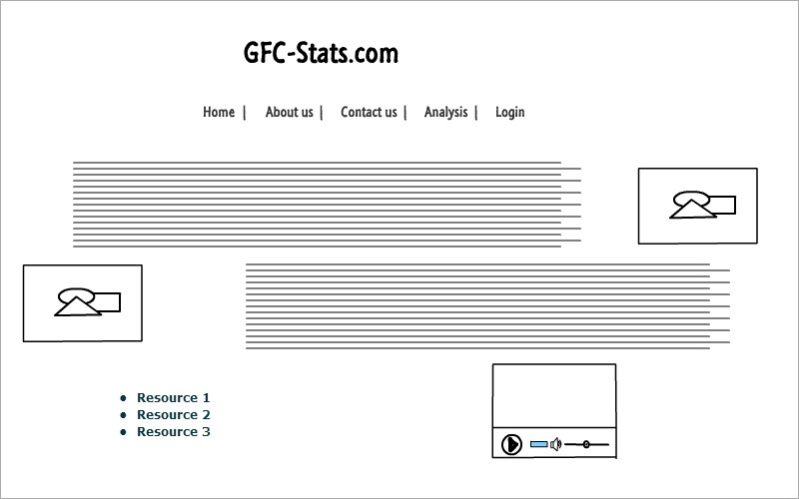

Contact us

The contatct us page is primarily an information source for users and offers details on the site how it works and some resources related to the topic for download or viewing on video

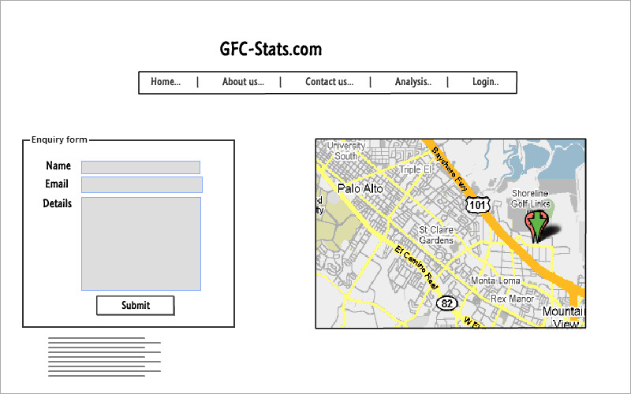

Profile - Analysis Page

This is the first real interaction page for the user where details will be input and feedback received. The user will fill one or both forms in the middle of the page and click a button to generate graphs and tables specific to their input.

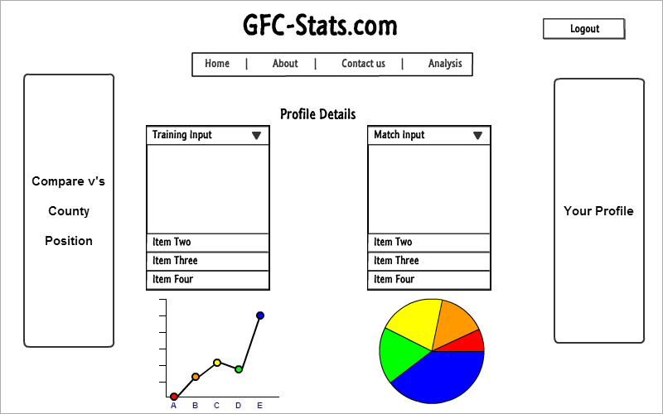

**Research Sites**

As part of the design and development of the Site concept, review and consideration were given to a number of similar sites currently on the Internet. The design implementations were therefore based on the functionality, CSS style, colour-schemes and access restrictions of a number of common and little know websites. In particular, the following sites should be noted:

* [www.jscharts.com/](http://www.jscharts.com/) – JS Charts functionality used in the Site
* [www.wikipedia.org](http://www.wikipedia.org) – used for Data input and Profile-Analysis Design
* <http://www.anatomyat1220.com/>
* <http://gaelicstats.com/>
* <http://www.sportplan.net/>
* <http://tocasports.com/>
* <http://www.statscool.com/>
* <https://dontfoul.wordpress.com/>
* [www.w3schools.com](http://www.w3schools.com) – used for CSS and Form functionality
* <https://developers.google.com/maps> – Google Maps API used in the Site

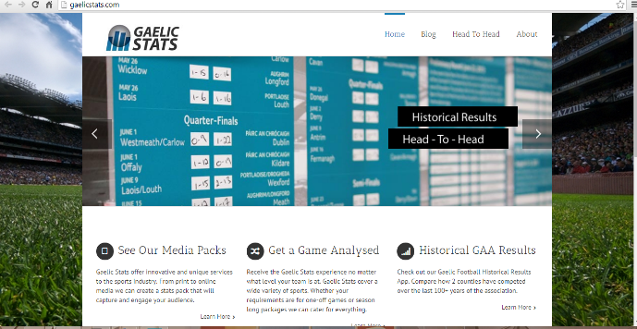

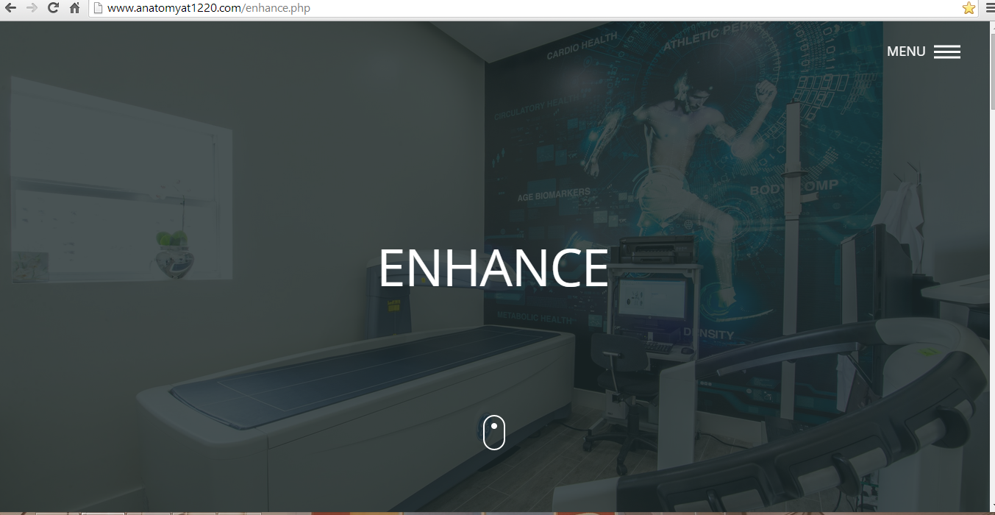

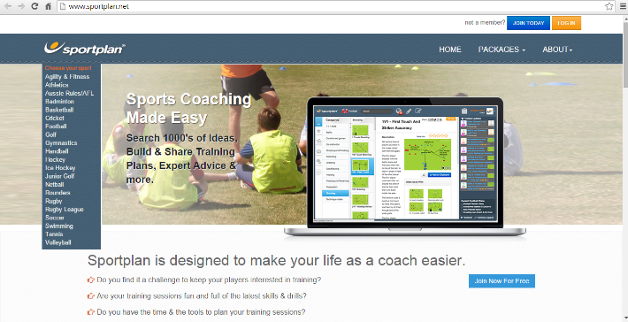 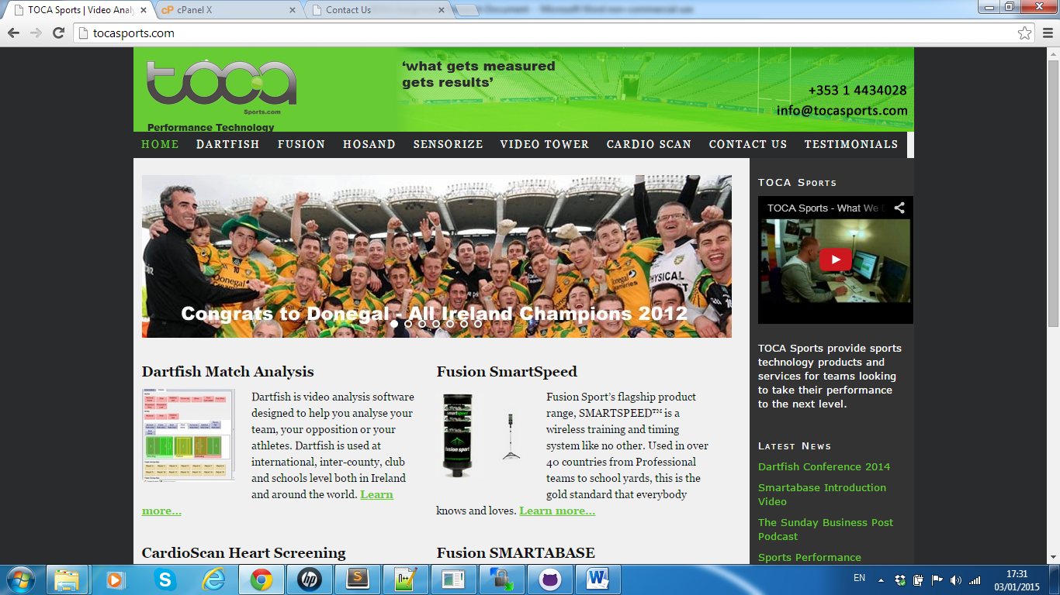

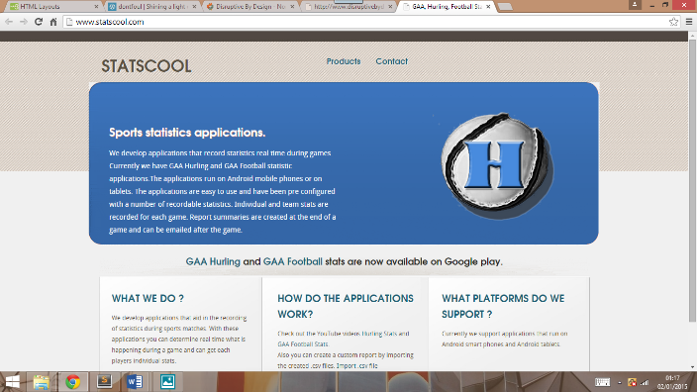 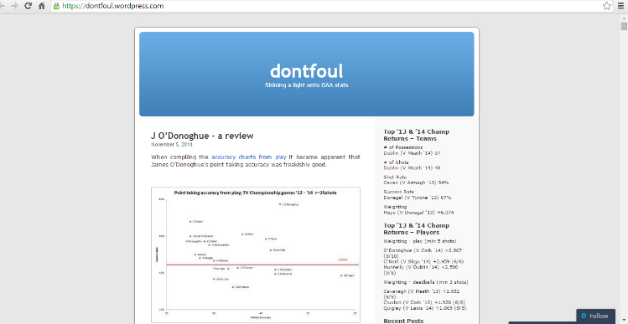

**Read-Me:**

For the benefit of prospective users, a ReadMe.txt file for more detailed granular information and process steps is available as part of our documentations. This will provided some guidance and directions for users new to the Site design on how to use / access the different pages, functionality and interfaces of the Website design.

**Home Page**

Linking on this page displays a number of images rotating in the centre of the screen with a live twitter feed on the column on the right and a number of links to points on the home page in the column to the left.

Across the top of the page is a navigation bar with a 5 options to link with the key pages. On hovering over these menu headings a submenu will appear offering links to a number of points on the various pages.

Scrolling down the page will allow the reader access to content according to the headings on the panel on the left hand side.

On the footer there are a number of ‘Sample links’ which are not connected for the purposes of this project as well as logos for connecting to twitter, facebook etc.

**About us Page**

This page has details on the project team and gives the user an understanding of how the site is used and how it can benefit them. Towards the end of the page are a few sample resources including pdf downloads, links to websites and a sample video embedded. The idea would be to grow the resource library for users giving them a variety of tools that could improve their performance.

**Contact us Page**

This page includes a form which the user can complete to send an enquiry as well as an embedded google map to find our base (GCD).

**Registration**

This page must be completed before the user can get into the site proper and use the analysis tools. The user must complete their details including selecting a username and password which is sha1 coded. The details the user includes become part of their initial profile and will be stored on the database for future reference.

**Login**

Once registered or if a user is previously registered they can go directly into the login page. Here they need to complete their username and password.

**Profile Analysis Page**

Once logged in the user will land on the Profile page. This page is the landing page for the back end site giving access to the main functionality of the site.

On the right hand side panel the details previously entered by the user will appear. On the left hand side there are a selection of links that the user can connect to for feedback on the input they have completed on the current visit as well as their historical data that can be retrieved.

In the centre of the page are two forms. These have been kept deliberately short to allow the user complete them quickly and get immediate feedback on their input.

**Training Details**

The first form relates to training data which offers a daily input. It was considered better to complete daily inputs to encourage constant return to the site and generate greater relationship with the users.

Each panel in the form must be completed in order:

**Date:** A date popup offers an easy way to fill in the day the training relates to

**Type of training:** A dropdown menu to choose whether the training was individual, with their club, or with their county.

**Injury Status**: Asks if the player had an injury at the time of the training or if they were ok.

**Skills Training**: Fill in the time spent doing skills training in minutes.

**Fitness Training**: Fill in the time spent doing fitness training in minutes.

**Gym Training**: Fill in the time spent doing Strength and Conditioning training.

**Recovery Time:** Fill in the time used for recovery after training.

**How would you like to compare your details**: Choose here if you want to compare against others that play in the same position as the user or compared to all the players.

**Would you like to save these changes:** Tick if yes. **NB If the box is not ticked no record will be added to the historical data for comparison purposes.

**Evaluate Training Button:** Once the form data has been filled and the relevant comparison and save buttons clicked this button can be used to display your results as compared with those against whom you have chosen to be measured.

* The output will appear below the form and will include a table and graph comparing averages per minute.

**Match Details**

The second form relates to key performance indicators for matches.

**Date of Match:** Record the date of the match which the data relates to.

**Type of Match:** Dropdown menu gives the option of club or county

**Minutes Played:** Records the time spent on the pitch during the match

**Distance covered in Meters**: Records the amount of running done during the match

**Number of Possessions**: How many possessions held by the player

**Passes Complete**: Records the number of successful passes made during the match

**Passes Incomplete:** Records the number of missed passes made

**Attempts**: Records the number of shots attempted by player

**Goals:** Records the number of goals scored

**Points**: Records the number of points scored

**How would you like to compare your details**: Choose here if you want to compare against others that play in the same position as the user or compared to all the players.

**Would you like to save these changes:** Tick if yes. **NB If the box is not ticked no record will be added to the historical data for comparison purposes.

**Evaluate Match Performance Button:** Once the form data has been filled and the relevant comparison and save buttons clicked this button can be used to display your results as compared with those against whom you have chosen to be measured.

* The output will appear below the form in and will include a table and graph comparing averages per minute

On the panel on the left hand side there are 3 options the user can click.

**Your Training Records**: This link will bring the user to a new page that brings up the training records the user has previously entered in a table format with an accompanying pie chart. If no records have been saved nothing will be displayed.

**Your Match Records:** This link will bring the user to a new page that brings up the match records the user has previously entered in a table format with an accompanying pie chart. If no records have been saved nothing will be displayed.

**Update User Details:** This link will bring the user to a new form similar to the one first completed on registration. It allows the user to update some of the static data that profiles the user.

**Logout Button:** When the user is finished using the analysis section of the site they must logout. Once logged out the user will be diverted to the Home page once more.